Государственное общеобразовательное учреждение
средняя общеобразовательная школа № 393
с углублённым изучением математики и информатики
Кировского района Санкт-Петербурга

XIII научно – практическая конференция
учащихся Кировского района

Секция: Английский язык
Вид работы: Исследование
Тема работы: The most popular English writer for lyceum №393

Выполнили: Горшкова Екатерина и Рзаева Наргиз
Ученицы 10 «а» класса
Научный руководитель: Дорожинская Любовь Михайловна

Санкт-Петербург
2012
Оглавление
Introduction 3
Biography of Joanne Katheline Rowling 4
Harry Potter movies 6
“Harry Potter” books 8
Shakespeare’s biography 9
Organization and methods of research 11
Researches’ organization 11
Researches’ methods 11
Polls’ results 12
Results of poll among pupils 12
Results of poll among students 12
Results of poll among adults 14
The general results of poll 14
Conclusion 15
Sources 16
Appendix 17

Introduction
In spite of technical progress books have been the main source of information, carrying us far away from our homes, in other times in fascinating exiting journeys. They show us this world from different sides. England is a country of talented detectives, powerful magicians, pretty nurses, one-way love and interesting destinies. Foggy Albion dazzles with stories, which fascinate, lure, attract readers attention. From the early childhood we read English fairytales, watch cartoons by their plots, grow and brought up on novels.
It is not difficult to call English writers’ works at once, but as it turns out it is much more difficult to call the writers’ names. And that is why we have got interested to know who in our schoolmates’ opinion is the most popular and famous writer.
For a very long time the whole world has admired the courageous magician and his adventures – Harry Potter. In the time of showing this film about three friends, Hogwarts students, cinema halls are overcrowded. Children, adults, teenagers read books about Harry Potter with great pleasure.
We considered that the author of “Harry Potter” books is the most popular writer among student, teachers and attendants of our lyceum. So we came out with the hypothesis than J. K. Rowling is the most popular English writer for “inhabitants” of our school.
So the aim of our investigation was to choose the most popular English writer among the people of our school: for pupils, students and adults.
And the object of our investigation is the opinion of our school “inhabitants”, the subject is choosing the most popular English writer
As the method of research we chose poll in which we had only one question – call the names of most famous English writers. And the author who receives the most would be the winner.
87 pupils (6-8 classes), 89 students (9-11 classes) and 14 adults took part in the poll.
Also you can find Rowlings’ and Shakespeares’ biography and some interesting information about “Harry Potter” book in our work.

Biography of Joanne Katheline Rowling
People of all ages know that she has written the book about Harry Potter, the boy who survived. We think that she currently is the most famous English writer.
The real name of writer is Joanne Rowling (Рисунок 2), not Joanne Katheline Rowling. Before her first publication, publishing house was afraid that boys won't buy book written by woman. Therefore Rowling was asked to use her initials instead of full name. Rowling didn't have second name, so she has chosen her grandma's name for second initial, Katheline – J. K. Rowling. In 2001 Joanne got married and took her husband's last name – Murray, but she still used her old name for writing.
Her parents, Peter James Rowling and Anne Rowling, met when on “King-Cross” station they were in the same coupe of train going to Arbort. On 14th of march 1965 they married in the north of London. After their marriage in 1965 they moved to Yate, Gloucestershire, England, 10 miles northeast of Bristol. On 31st of July 1965 Joanne was born. She has a sister, Diana, who is 2 years younger than Joanne.
When Joanne was 4 years old, her family moved to Winterbourne village. There she and her sister played with the boy and the girl whose last name was Potter. Joanne attended St Michael's Primary School.
Anne spent all her time with daughters. She read them books, and Joanne learned almost all the books by heart at the age of five. When she was six, the fairy tale about a sick rabbit and his friends was her principal literary achievement.
When Joanne was 15, her mother got sick with multiple sclerosis.
During her last year at school, Joanne decided to enter University of Oxford. She successfully passed entrance exams, but she didn't become a student of the prestige university. Joanne decided not to try again and not to waste a year, so she entered Exeter university in Devon in 1983. She wanted to study English, but her parents insisted on her going to French faculty.
After graduating from university as bachelor of arts, she moved to Forx, where she changed several jobs. In 1990 she moved to Manchester.
Joanne's mother, who was paralyzed for several years, died on 30th of December 1990. After this Joanne decided to move from England to Portugal.
In 1991 Joanne moved to Portugal to teach English. She was giving lessons after dinner and in th evening, and was writing in the morning. At this point she began writing on her 3rd book. The previous two weren't finished because she considered them “very bad”. New book was about a boy, who found out that he is a magician, and went to a magic school.
In August 1992 in Portgal she married a student journalist Jorge Arantes . In 1993 daughter Jessica was born. Very soon her husband wanted to divorce and so Rowling with her daughter moved to Edinburgh, Scotland, closer to her younger sister.
In Edinburgh Joanne went to “Nicolson's” cafe, which was owned by her sister's husband, to write “Harry Potter”.
Scottish Arts Council gave her grant to finish the book, and, after several dinials, she has finally sold the book «Harry Potter and the Philosopher's Stone» to “Bloomsbury” publishing house for USD $4000. At that moment Joanne was a French teacher.
A few months later Scholastic Inc has bought the right to publish the book in US for money big enough for Joanne to quit teaching.
«Harry Potter and the Philosopher's Stone» came out in June 1997 and was a great success became a sensation – a novel by new and unknown writer was named the best child book of year in Great Britain.
After the first book others followed, “Harry Potter and the Chamber of Secrets” in 1998, “Harry Potter and the Prisoner of Azkaban” in 1999, “Harry Potter and the Goblet of Fire” in 2000.
“Harry Potter and the Order of the Phoenix” in 2003, “Harry Potter and the Half-Blood Prince” in 2005. Seventh, and the last book “Harry Potter and the Deathly Hallows” was published in UK, US and several other countries in 2007.
In 1998 Warner Brothers bought the right to make movies based on two Rowling's books.
In 2001 “Harry Potter and the Philosopher's Stone”, produced by Chris Columbus, came out. Chris also produced the second movie, “Harry Potter and the Chamber of Secrets”. Movies based on third, fourth and fifth books came out in 2004, 2005, 2007 accordingly. Sixth movie was released in 2009. Movie for the last, seventh book was split in two parts, which came out in 2010 and 2011 accordingly.
Harry Potter series were translated into more than 35 languages. 8 films were created based on her books, which became very popular.
Success of series and movies have brought Rowling fame and money. Since 2004 Rowling is the richest women of UK. Forbes magazine estimated her to have $1 billion in 2008.
Rowling got many literature awards, including Nestle Smarties Gold Award (3 times), British Book Awards, Children’s Book Award (twice), The Booksellers Association/The Bookseller Author of the Year Award (twice), Scottish Arts Council Children’s Book Award (twice), Premio Príncipe de Asturias (Spanish).
In 2000 Rowling was awarded with Order of British Empire.
On 4th of December 2008 in 25 countries, including Russia, Joanne's new book “The Tales of Beedle The Bard” started selling. All money from book sales will be sent to The Children’s High Level Group charity, protecting children's rights in Eastern Europe. However, Rowling is planning to write encyclopedia about all Harry Potter books.
Rowling actively supported charity. She supports single parents fund and multiple sclerosis research fund – that was disease her mother died of.
On 26 December 2001 Joanne married Neil Scott Murray. In March of 2003 their son, David Gordon Rowling Murray, was born, and in January of 2005 – daughter Mackenzie Jean Rowling Murray.

Harry Potter movies
In October 1998, Warner Brothers purchased the film rights to the first two novels for a seven-figure sum. A film adaptation of «Harry Potter and the Philosopher's Stone» were released on 16 November 2001, and «Harry Potter and the Chamber of Secrets» on 15 November 2002. Both films were directed by Chris Columbus (Рисунок3). 4 June 2004 saw the release of the film version of «Harry Potter and the Prisoner of Azkaban», directed by Alfonso Cuarón. The fourth film, Harry «Potter and the Goblet of Fire», was directed by another new director, Mike Newell, and released on 18 November 2005. The film of «Harry Potter and the Order of the Phoenix» was released on 11 July 2007. David Yates directed, and Michael Goldenberg wrote the screenplay, having taken over the position from Steve Kloves. «Harry Potter and the Half-Blood Prince» was released on 15 July 2009. David Yates directed again, and Kloves returned to write the script. In March 2008, Warner Bros. announced that the final instalment of the series, «Harry Potter and the Deathly Hallows», would be filmed in two segments, with part one being released in November 2010 and part two being released in July 2011. Yates would again return to direct both films.
Warner Brothers took considerable notice of Rowling's desires and thoughts when drafting her contract. One of her principal stipulations was the films be shot in Britain with an all-British cast, which has been adhered to strictly. In an unprecedented move, Rowling also demanded that Coca-Cola, the victor in the race to tie in their products to the film series, donate $18 million to the American charity Reading is Fundamental, as well as a number of community charity programs.
The first four, sixth and seventh films were scripted by Steve Kloves (Рисунок 4); Rowling assisted him in the writing process, ensuring that his scripts did not contradict future books in the series. She has also said that she told Alan Rickman (Severus Snape) and Robbie Coltrane (Hagrid) certain secrets about their characters before they were revealed in the books. Daniel Radcliffe (Harry Potter) asked her if Harry died at any point in the series; Rowling answered him by saying, «You have a death scene», thereby not explicitly answering the question. Director Steven Spielberg was approached to helm the first film, but dropped out. The press has repeatedly claimed that Rowling played a role in his departure, but Rowling stated that she has no say in who directs the films and would not have vetoed Spielberg if she had. Rowling's first choice for the director had been Monty Python member Terry Gilliam, as she is a fan of his work. However, Warner Brothers wanted a more family friendly film and eventually they chose Chris Columbus, who was set to direct all seven entries in the series. Columbus declined to direct the succeeding films to the second adaptation as he claimed he was "burned out". This led to directors Alfonso Cuarón, Mike Newelland David Yates to join the series. Cuaron and Newell helmed one film each, while Yates directed the final four entries.
Rowling had gained creative control on the films, approving all the scripts as well as acting as a producer on the final two-part instalment, Deathly Hallows.
On her website, Rowling revealed that she was considered to have a cameo in the first film as Lily Potter in the Mirror of Erised scene. Rowling, however, turned down the role, stating that she was not cut out to be an actor and, "would have messed it up somehow". The role ultimately went to Geraldine Somerville.
Rowling, producers David Heyman and David Barron, along with directors David Yates, Mike Newell and Alfonso Cuarón collected the Michael Balcon Award for Outstanding British Contribution to Cinema at the 2011 British Academy Film Awards in honour of the Harry Potter film franchise.
In 2000, after a seven month search, lead actor Daniel Radcliffe was discovered by producer David Heyman and writer Steve Kloves seated just behind them in a theatre. In Heyman's own words, "There sitting behind me was this boy with these big blue eyes. It was Dan Radcliffe. I remember my first impressions: He was curious and funny and so energetic. There was real generosity too, and sweetness. But at the same time he was really voracious and with hunger for knowledge of whatever kind.
Also in 2000, the unknown British actors Emma Watson and Rupert Grint were selected from thousands of auditioning children to play the roles of Hermione Granger and Ron Weasley, respectively. Prior to them being chosen, their only previous acting experience was in school plays. Grint was eleven years old and Watson ten at the time they were cast.

“Harry Potter” books
The novels revolve around Harry Potter, an orphan who discovers at the age of eleven that he is a wizard, living within the ordinary world of non-magical, or muggle, people. His ability is inborn and such children are invited to attend a school that teaches the necessary skills to succeed in the wizarding world. Harry becomes a student at Hogwarts School of Witchcraft and Wizardry and it is in here where most of the novels' events take place.
Each book chronicles one year in Harry's life with the main narrative being set in the years 1991–1998. The books also contain many flashbacks, which are frequently experienced by Harry viewing the memories of other characters in a device called a Pensieve.
The environment J. K. Rowling created is completely separate from reality but intimately connected to it. The wizarding world of Harry Potter exists in parallel within the real world and this is how Potter's world contains magical elements similar to things in everyday life. Many of its locations are recognizable, such as London.
- A picture of Gandalf the Grey (from The Lord of the Rings) can be seen in the collection of great wizards in Professor Dumbledore’s study in Harry Potter and the Chamber of Secrets.
- Rowling is the first person to become a billionaire (U.S. dollars) by writing books.
- Harry’s birthday is July 31, 1980. Rowling’s birthday is also July 31—but in 1966.
- The name Voldemort comes from the French words meaning «fly from death», and his entire goal is to conquer death. In the second Harry Potter novel, Rowling shows us that «I am Lord Voldemort» is an anagram of «Tom Marvolo Riddle», which is his actual full name.
- Natalie McDonald, who appeared in Harry Potter and Goblet of Fire, was based on a real girl Rowling knew who was dying of leukemia
- A theme park called the Wizarding World of Harry Potter was opened in 2010 at Universal Islands of Adventure in Florida. The park includes a Hogwarts School of Witchcraft and Wizardry, the Forbidden Forest, and Hogsmeade Village.

Shakespeare’s biography
The actual date of Shakespeare's birth is not known, but April 23, St George's Day, has been Shakespeare's accepted birthday, and a house on Henley Street in Stratford, owned by William's father, John, is accepted as Shakespeare's birth place.
Waves of the plague swept across the countryside, and pestilence ravaged Stratford during the hot summer months. Mary and John Shakespeare became parents for the first time in September of 1558, when their daughter Joan was born. Nothing is known of Joan Shakespeare except for the fact that she was baptized in Stratford on September 15, and succumbed to the plague shortly after. Their second child, Margaret, was born in 1562 and was baptized on December 2. She died one year later. The Shakespeares' fourth child, Gilbert, was baptized on October 13, 1566, at Holy Trinity. In 1569, John and Mary Shakespeare gave birth to another girl, and named her after her first born sister, Joan. Shakespeares' joy was heightened with the birth of their fourth daughter, Anne, in 1571, when William was seven years old. Unfortunately, tragedy befell the family yet again when Anne died at the age of eight. In 1574, Mary and John Shakespeare had another boy and they named him Richard. Mary gave birth to one more child in 1580.
Shakespeare (Рисунок1) probably began his education at the age of six or seven at the Stratford grammar school, which is still standing only a short distance from his house on Henley Street and is in the care of the Shakespeare Birthplace Trust. Like all of the great poets and dramatists of the time, Shakespeare learned his basic reading and writing skills from an ABC, or horn-book.
Recordings in the Episcopal register at Worcester on the dates of November 27 and 28, 1582, reveal that Shakespeare desired to marry a young girl named Anne. She was a farmer's daughter and she was some years older than himself. Shakespeare had three children: Susannah, the eldest, then twins - a son, Hamnet, and another girl, Judith. In 1587 Shakespeare went to work in London, leaving Anne and the children at home.
Some years later Shakespeare began to write plays. By 1592 Shakespeare was an important member of well-known company. In 1599 the famous Globe Theatre was built on the south bank of the river Thames. In that theatre most of his plays were performed. It was a round building with the stage in the center, open to the sky. If it was raining, the actors got wet; if the weather was too bad, there was no performance at all. By 1603 Shakespeare was the leading poet and dramatist of his time. He continued to write for the next ten years. In 1613 he finally stopped writing and went to live in Stratford where he died in 1616. He is buried in Stratford-on-Avon.
87th sonnet
Farewell! thou art too dear for my possessing,
And like enough thou know’st thy estimate,
The charter of thy worth gives thee releasing;
My bonds in thee are all determinate.
For how do I hold thee but by thy granting?
And for that riches where is my deserving?
The cause of this fair gift in me is wanting,
And so my patent back again is swerving.
Thy self thou gavest, thy own worth then not knowing,
Or me to whom thou gav’st it else mistaking;
So thy great gift, upon misprision growing,
Comes home again, on better judgement making.
Thus have I had thee, as a dream doth flatter,
In sleep a king, but waking no such matter.
Перевод (по Н.В. Гебелю)
Прощай - ты для меня уж слишком дорога;
Да и сама себе ты, верно, знаешь цену.
Нажив достоинств тьму, ты сделалась строга;
Я ж, став твоим рабом, нейду на перемену,
Чем, кроме просьб, тебя могу я удержать,
И чем я заслужил такое совершенство?
Нет, не по силам мне подобное блаженство,
И прав я на него не вправе заявлять.
Ты отдала себя, цены себе не зная,
Иль - может - как во мне, ошиблась ты в себе.
И вот, случайный дар мне милый возвращая,
Я вновь его дарю, прекрасная, тебе.
Да, ты была моей, но долго ль это было?
Я спал - и был царем, проснулся - и все сплыло.

Organization and methods of research

Researches’ organization
Research objective is to reveal the most known English writer, among pupils and adults of lyceum №393.
Hypothesis: Joanne Rowling is the most known English writer for lyceums’ people.
For achievement of aim it is necessary to solve following tasks
- To conduct poll among pupils (6-8 classes), students (9-11 classes) and adults
- The choice of the most popular English writer in opinion of lyceums’ people
- To acquaint yourself with Rowlings’ biography and some interesting information about her book
87 pupils (6-8 classes), 89 students (9-11 classes) and 14 adults took part in the poll.

Researches’ methods
As a method of research we chose the poll. We have divided all "inhabitants" of our school into three groups: pupils (6-8 classes), students (9-11 classes) and adults (teachers and attendants). We asked participants to write down one or more English writers who they consider to he the most popular. Then we summarized votes. And the author who received the most votes was chosen as the winner.

Polls’ results

Results of poll among pupils
Having interrogated pupils we stated that J. Rowling is the most known writer among the children of our lyceum. The results of inquiry are given in Table1.
Таблица 1
 | 6 class | 7 class | 8 class | Total
J.Rowling | 2 | 10 | 10 | 22
A.Doyle | 3 | 4 | 10 | 17
H.C. Andersen | 13 | 2 | 0 | 15
J. London | 9 | 2 | 3 | 14
L. Karrol | 6 | 2 | 0 | 8
W. Shakespeare | 0 | 2 | 4 | 6
R. Bradbury | 3 | 2 | 0 | 5
G. Byron | 0 | 3 | 1 | 4
M.Twain | 1 | 0 | 1 | 2
A. Christie | 0 | 2 | 0 | 2
S. King | 0 | 2 | 0 | 2
J. Tolkien | 0 | 0 | 2 | 2

Results of poll among students
From the results given in Table2 it is obvious that J. Rowling is the most famous writer for students of our school.

Таблица 2
 | 9 | 10 | 11 | Total
J. Rowling | 4 | 9 | 12 | 25
A. Doyle | 8 | 7 | 7 | 22
W. Shakespeare | 7 | 6 | 1 | 14
J. London | 0 | 5 | 5 | 10
J. Tolkien | 3 | 1 | 3 | 7
A. Christie | 2 | 2 | 0 | 4
S. King | 0 | 0 | 4 | 4
C. Dickens | 1 | 0 | 3 | 4
M.Twain | 0 | 1 | 2 | 3
G. Byron | 0 | 3 | 0 | 3
Brontë | 0 | 1 | 2 | 3
T. Pratchett | 0 | 0 | 3 | 3
R. Bradbury | 0 | 1 | 1 | 2
H.C. Andersen | 0 | 2 | 0 | 2
L. Karrol | 0 | 1 | 0 | 1

Results of poll among adults
Shakespeare had been selected as the most famous writer by adults of our school. Results of inquiry are presented in Table3Таблица 3
Writer | Votes
W. Shakespeare | 6
G. Byron | 3
C. Dickens | 3
A. Doyle | 2
W.Thackeray | 2
A. Christie | 1
J. London | 1
J. Austen | 1
J. Tolkien | 1
L. Karrol | 1

The general results of poll
So at the end the results were as follow, given – Table4
Таблица 4
Writer | Votes
J. Rowling | 47
A. Doyl | 41
W. Shakespeare | 26
J. London | 25
H.C. Andersen | 17

Conclusion
During research we have clarified that the most known writer at our school is Joanne Rowling. Our hypothesis is true. And also we have defined the most popular writers for each of groups: for adults it is Shakespeare, for students and pupils - Rowling. Though our lyceum mathematical our research has shown that children are well informed in the literature too.

Sources
- Britain in close-up. 2001
- The world of English. Rongman, 1997
- What a world. Milada Broukal. Longman 2005
- Поттериада — Мир Гарри Поттера http://potteriada.ru/
- J.K. Rowling official site http://www.jkrowling.com/
- Shakespeare online http://www.shakespeare-online.com/
- Шекспир У. Сонеты/ на английском языке с параллельным русским текстом – СПб.: «АНИМА», 2001. – 320с., портр.

Appendix

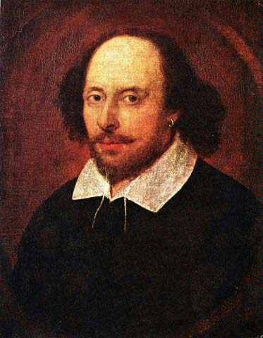
Рисунок 1. W. Shakespeare

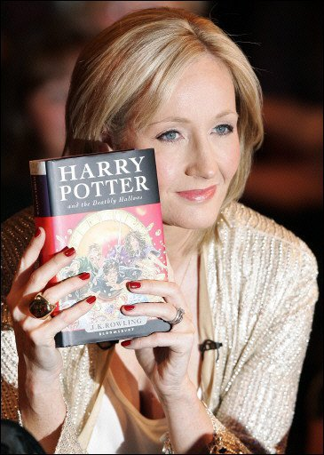
Рисунок 2. J. Rowling
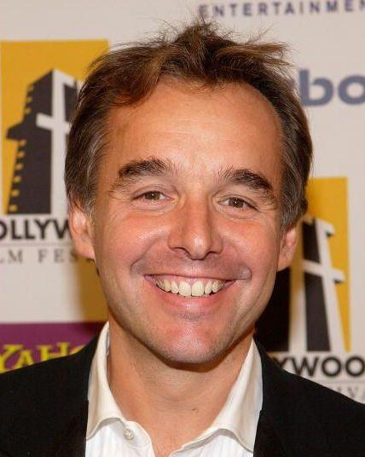
Рисунок 3. Chris Columbus
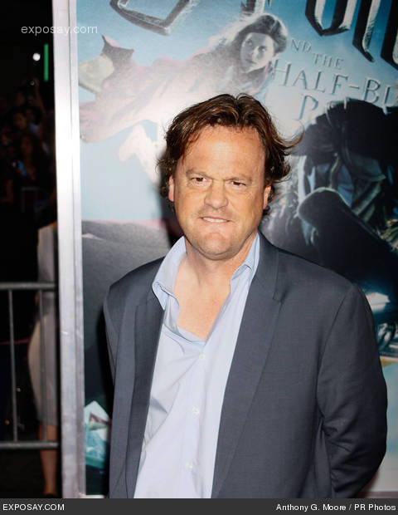
Рисунок 4. Steve Kloves

J.K. Rowling official site http://www.jkrowling.com/en/
Поттериада — Мир Гарри Поттера http://potteriada.ru/biografii/biografiya-dzhoan-ketlin-rouling
J.K. Rowling official site http://www.jkrowling.com/en/
Поттериада — Мир Гарри Поттера http://potteriada.ru/biografii/biografiya-dzhoan-ketlin-rouling
Поттериада — Мир Гарри Поттера http://potteriada.ru/biografii/biografiya-dzhoan-ketlin-rouling
Поттериада — Мир Гарри Поттера http://potteriada.ru/biografii/biografiya-dzhoan-ketlin-rouling
Shakespeare online http://www.shakespeare-online.com/biography/shakespearebirth.html
Шекспир У. Сонеты. Стр. 178
Шекспир У. Сонеты. Стр. 179

